February 2023

Dear Friends of the Northeast Iowa Dairy & Agriculture Foundation,
Thank you for all you do in supporting Iowa’s agriculture industry and the producers who make it so great. We have an exciting agenda lined up for the Northeast Iowa Dairy & Agriculture Foundation’s 2023 annual meeting and are asking for your participation in this event scheduled for Wednesday, March 15. Show our membership your continued support by being a sponsor of this event.
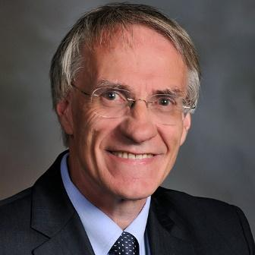
This year’s speaker will be Dave Kohl, Ph.D., an academic Hall of Famer in the College of Agriculture at Virginia Tech, Blacksburg, VA. His presentation will focus on High Octane Business Strategies. Dr. Kohl has keen insight into the agriculture industry gained through extensive travel, research, and involvement in ag businesses. He has traveled over 10 million miles; conducted more than 7,000 presentations; and published more than 2,500 articles in his career. Dr. Kohl’s wisdom and engagement with all levels of the industry provide a unique perspective into future trends. Additional meeting details will be announced in the coming weeks.
We are asking your support of the annual meeting through purchasing ad space in our 2023 annual report. Report books are distributed to attendees at the meeting and are available to download on our website. All our rates for ads in the annual report remain the same as the past. If you have advertised in the past, enclosed is a copy of the ad you previously ran. In addition, booth space at the event is available for sponsors. Should you request booth space, please indicate your preferences on the enclosed form.
Supporters have always had an essential role in making our annual meeting a success. Please review and return the enclosed sponsorship form no later than Friday, March 3. If you have any questions regarding the annual meeting or sponsorship, please contact me at lawsteund@nicc.edu or 844.642.2338, ext.1112.

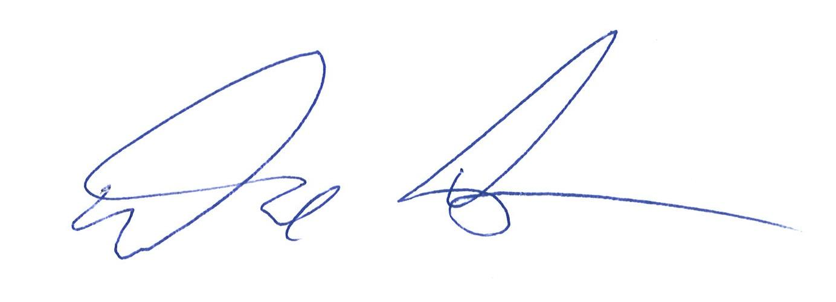
Sincerely,

David Lawstuen
Chair, Northeast Iowa Dairy & Agriculture Foundation

